**PRACTICAL NO 6**

**AIM :** Develop application to download image/video from server or upload image/video to server using MTOM techniques

**SOLUTION:**

**Step 1 :** Inside the project folder create a new file named app.py and write the following code

from flask import Flask, request, send_from_directory

import os

app = Flask(__name__)

UPLOAD_FOLDER = 'uploads'

os.makedirs(UPLOAD_FOLDER, exist_ok=True)

@app.route('/upload', methods=['POST'])

def upload_file():

    file = request.files.get('file')

    if file:

        file_path = os.path.join(UPLOAD_FOLDER, file.filename)

        file.save(file_path)

        return {"message": f"File '{file.filename}' uploaded successfully!"}, 200

    return {"error": "No file uploaded"}, 400

@app.route('/download/<filename>', methods=['GET'])

def download_file(filename):

    try:

        return send_from_directory(UPLOAD_FOLDER, filename, as_attachment=True)

    except FileNotFoundError:

        return {"error": "File not found"}, 404

if __name__ == '__main__':

    app.run(debug=True)

**Step 2 :** Run the app.py code

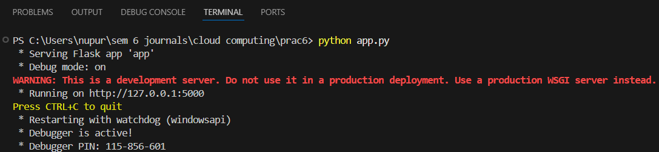

**Step 3 :** Open Postman API and and select POST request

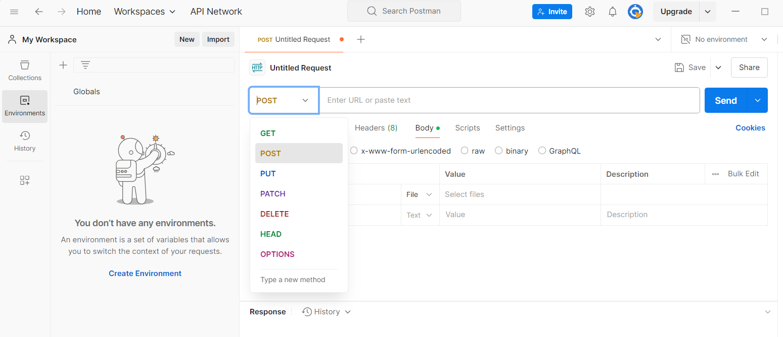

**Step 4 :** Enter the following url : http://127.0.0.1:5000/upload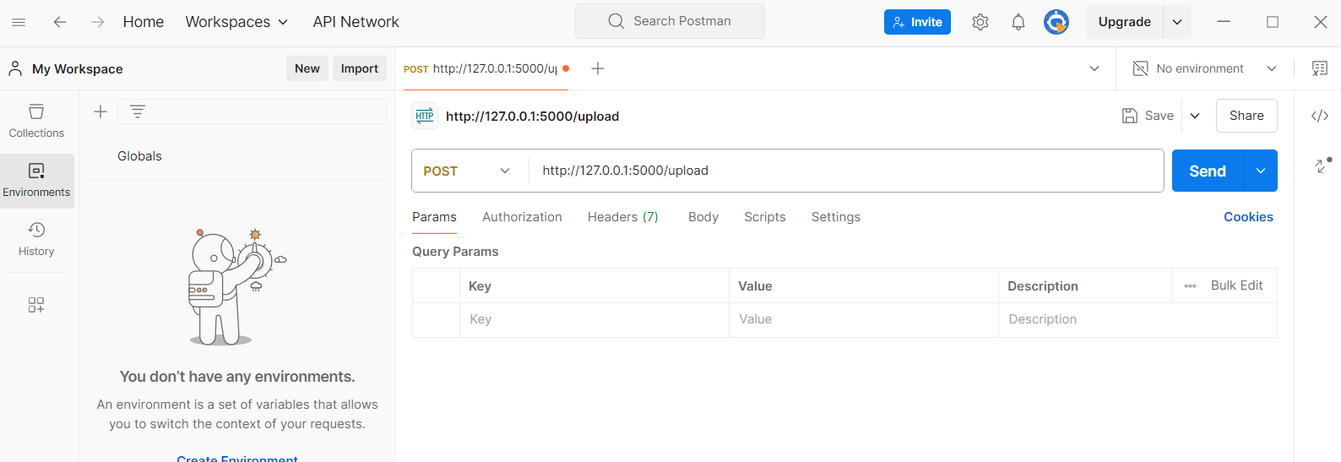

**Step 5 :** Click on Body and select form-data

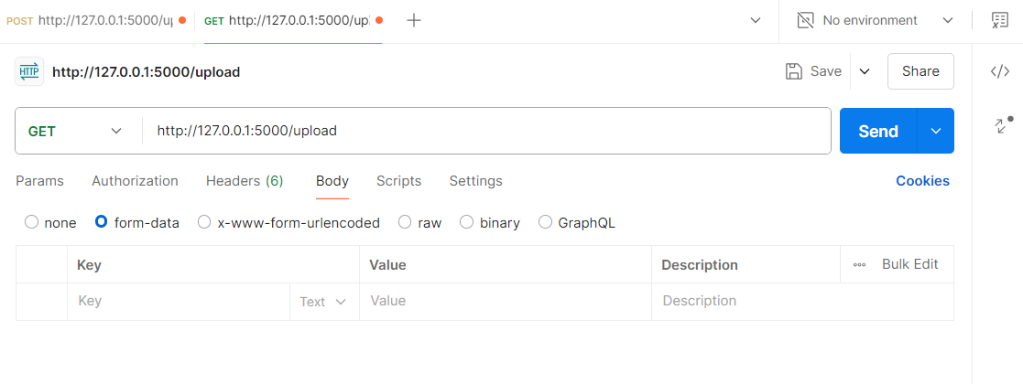

**Step 6 :** Select file and name it as ‘file’

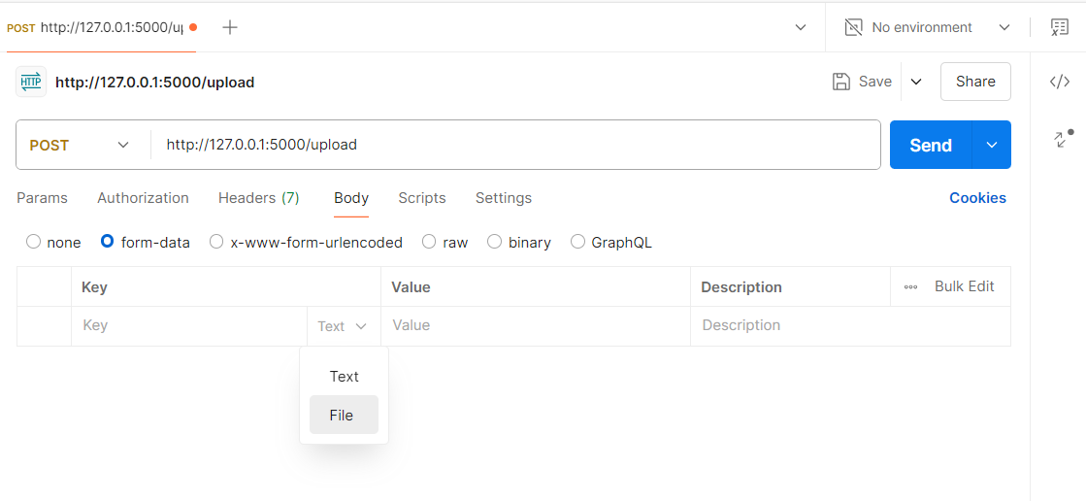

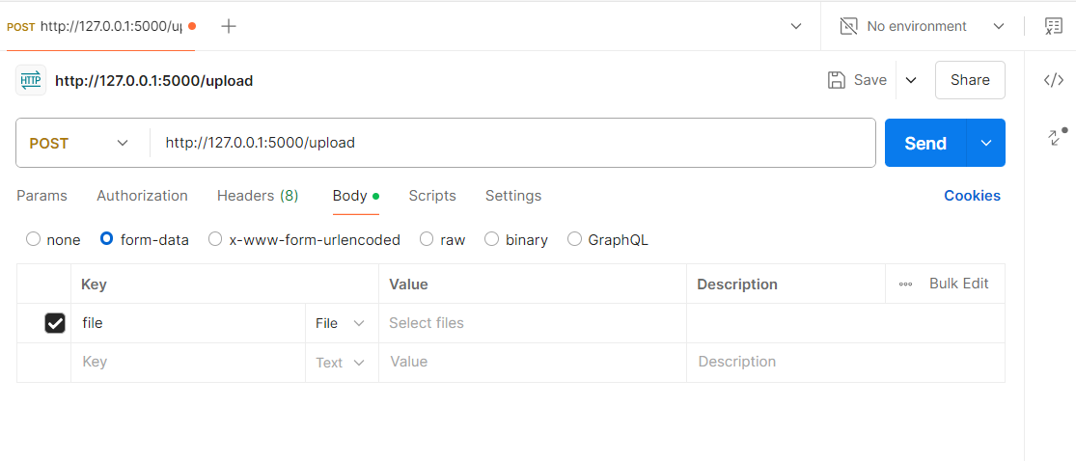

**Step 7 :** In the value section Click on Select files and then click on New file from local machine

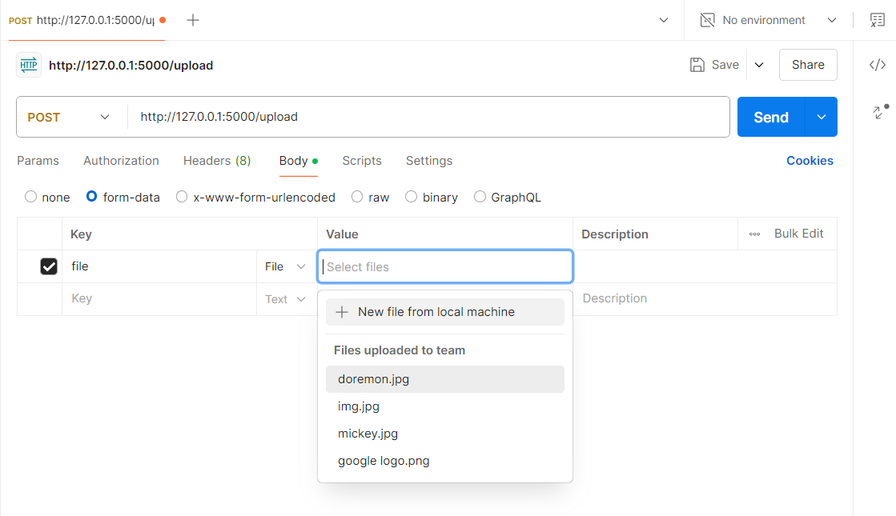

**Step 8 :** Click on the Cloud button to upload the image

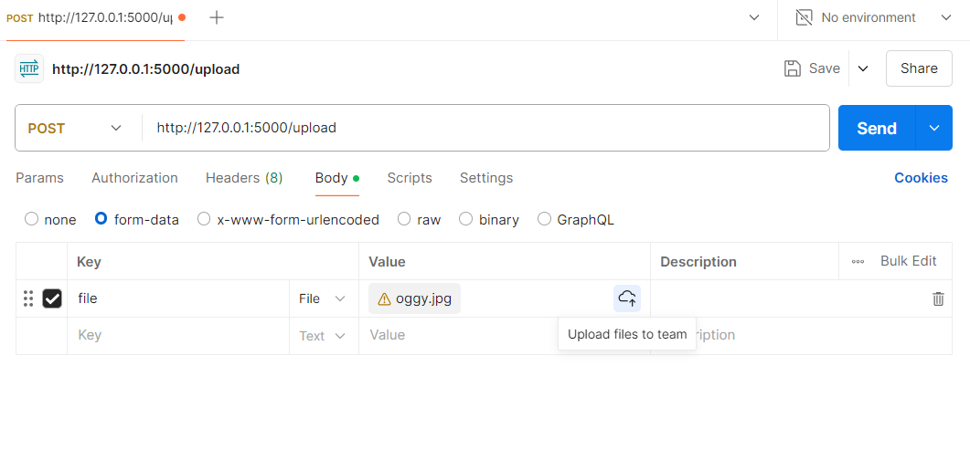

**Step 9 :** Click on Send and You will get to see the following output

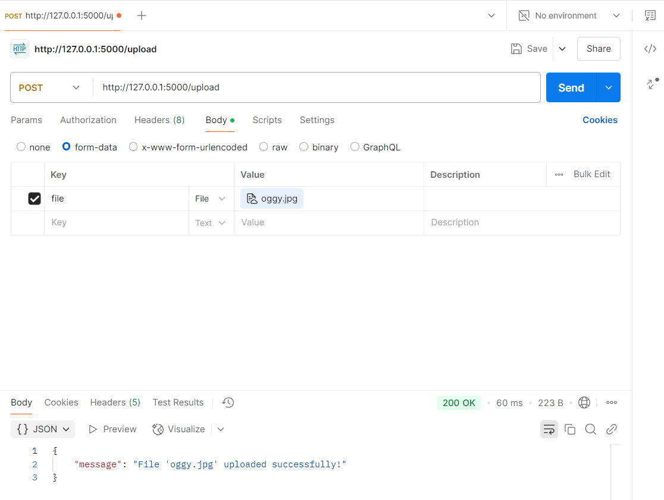



**Step 10 :** Now Go to Vscode and inside the upload folder you will see the image you uploaded in Postman

